group | N | Mean | Minimum | Std Dev | Lower Quartile | Median | Upper Quartile | Maximum
A | 59 | 28.6 | 5.0 | 15.6 | 18.0 | 25.0 | 36.0 | 80.0
B | 39 | 32.0 | 4.0 | 20.0 | 15.0 | 25.0 | 50.0 | 78.0
P=0.6869 from Wilcoxon Two Sample Test.

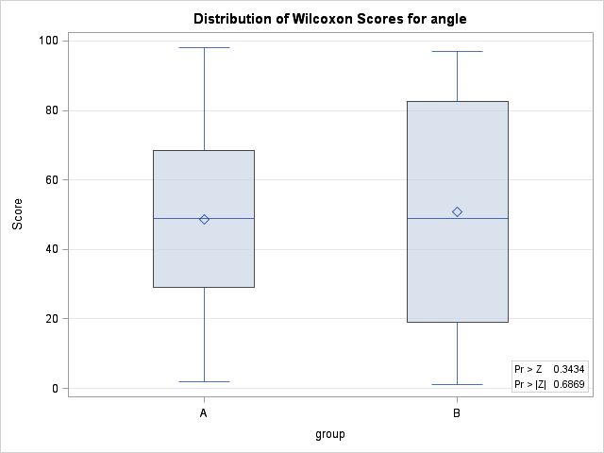

idx=0~25 (p=0.0461)
Analysis Variable : angle
group | N | Mean | Minimum | Std Dev | Lower Quartile | Median | Upper Quartile | Maximum
A | 28 | 16.7 | 5.0 | 4.6 | 14.0 | 17.5 | 20.0 | 24.0
B | 16 | 13.8 | 4.0 | 4.6 | 10.0 | 14.0 | 16.5 | 21.0

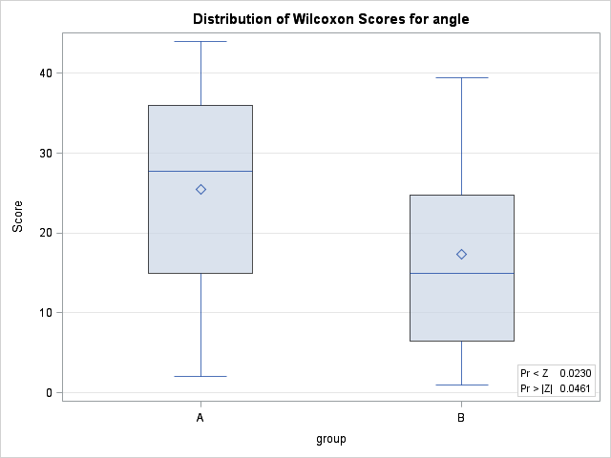

idx=25~40(p=0.98)
Analysis Variable : angle
group | N | Mean | Minimum | Std Dev | Lower Quartile | Median | Upper Quartile | Maximum
A | 19 | 30.3 | 25.0 | 4.9 | 25.0 | 29.0 | 34.0 | 40.0
B | 11 | 30.5 | 25.0 | 6.0 | 25.0 | 30.0 | 37.0 | 40.0

idx=>40(p=0.34)
Analysis Variable : angle
group | N | Mean | Minimum | Std Dev | Lower Quartile | Median | Upper Quartile | Maximum
A | 12 | 53.7 | 41.0 | 11.9 | 44.0 | 51.5 | 58.5 | 80.0
B | 12 | 57.8 | 44.0 | 10.7 | 50.0 | 55.5 | 66.5 | 78.0

